Configuring Follow-Up and Closure
in D365 Case Management Agent (CMA)
Dynamics 365 Customer Service | Copilot & AI

📌 Demo environment: The scenario, customer, and case data in this article are fictitious and for illustration purposes only.

The Story
Henry Parker owns a small specialty coffee shop in Seattle. He relies on his Contoso BrewMaster 3000 to power through the morning rush. One Tuesday, mid-brew, the machine suddenly stops and displays ERR-04 — a Steam Pressure Sensor Fault.
Henry opens a support case with Contoso Coffee Machines:
Case #CAS-01106-T7J5X5
Case Title: ERR-04 Steam Pressure Fault - BrewMaster 3000
Description: BrewMaster 3000 is showing ERR-04 and won't brew.
A support agent acknowledges the case, sends troubleshooting steps, and sets the case status to Waiting for Details. Henry is busy running his shop — he doesn't respond.
Without automation, this case could sit open indefinitely. With the Case Management Agent (CMA) configured for follow-up and closure, the system takes over: it sends follow-up emails automatically every 5 hours, up to 3 times total, and closes the case if the customer never responds — all without any agent intervention.

Autonomous vs. Human-Confirmed Follow-Ups
Not every case should be handled autonomously. A machine error like ERR-04 has a known resolution path — CMA can handle it end-to-end. But sensitive cases like contract renewals or pre-sales inquiries may require an agent to review each follow-up before it reaches the customer.
CMA solves this by letting you create separate rules per case type, each with its own automation level:
Case Type | Case Title Contains | Follow-up Mode
Machine errors / technical faults | ERR-, Fault, Not Working | Full automation
Commercial topics (contracts, pre-orders) | (separate rule) | Require human confirmation

This article focuses on the Full Automation rule for machine error cases.

Step 1 — Create the Follow-Up Rule and Define Conditions
Navigate to Customer Service admin center → Agent experiences → Case Management Agent → Follow-up and closure and create a new rule.

Rule Details
Rule name: Full Automation
Give the rule a name that clearly signals its intent. This matters when you have multiple rules — agents and administrators need to understand at a glance which rule applies to which case type.

Conditions
The Conditions section defines which cases this rule applies to. This is the routing decision point that separates autonomous follow-ups from human-confirmed ones.
Condition name: Follow-up for cases involving machine issues
Condition logic: The outer connector is And — all top-level condition groups must pass. Inside the group, the connector is Or — the case only needs to match one keyword row.
Three rows are configured using Contains (not Equals) so the keyword matches anywhere in the case title:
Field | Operator | Value | What it catches
Case Title | Contains | ERR- | All structured error codes: ERR-04, ERR-01, ERR-12…
Case Title | Contains | Not Working | Plain-language: "machine not working", "won't brew"
Case Title | Contains | Fault | Descriptive: "Steam Pressure Fault", "Sensor Fault"

⚠️ Use Contains (not Equals) for each row — it matches the keyword anywhere in the case title. Use Or between rows — a single match is enough to trigger the rule.

Level of Automation
Two options are available:
- Require human confirmation — Adds a confirmation step for agents before CMA sends any follow-up. Use this for contracts, escalations, complaints, or pre-sales inquiries.
- Full automation ← selected — Allows CMA to send follow-up emails and resolve cases automatically. No agent action required after the initial response.
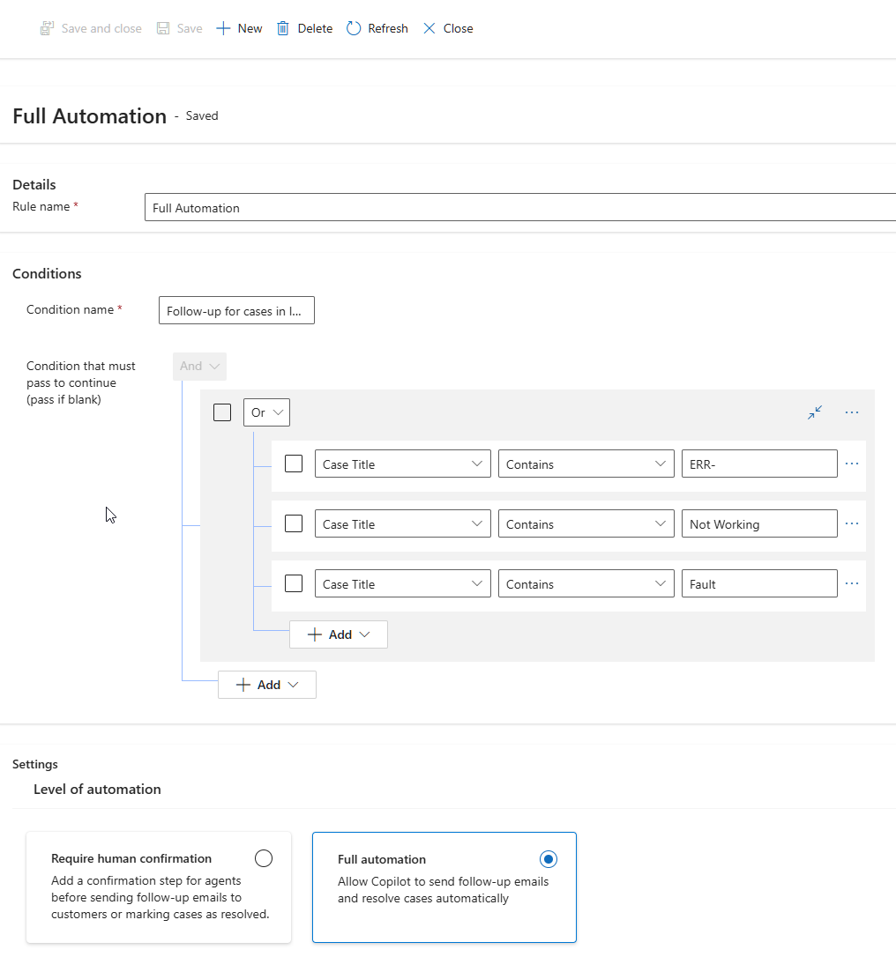
Figure 1 — Full Automation rule: Case Title conditions with OR logic and Full Automation selected

Step 2 — Configure Follow-Up Behavior

Attributes for Reference
Set Data to Case Title and Case Number. CMA uses these fields to personalize each follow-up email with the specific case details, making messages professional and traceable.

Follow-Up Trigger
Defines what event starts the follow-up clock. Both options are enabled in this demo:
- Follow-up based on context — CMA reads email exchanges and uses AI to determine when to follow up, even if the agent forgot to update the case status.
- Follow-up based on status reason — CMA watches for a specific case status and starts the follow-up clock the moment it is set.
⚠️ CRITICAL — Status Reason: Waiting for Details
This is the most important step in the entire configuration. CMA only begins following up once an agent explicitly sets the case status to Waiting for Details. This signals that the agent has responded and CMA should take over.
Agents MUST set this status after sending their initial response. Without it, no follow-ups will be sent — regardless of how the rule is configured.

Number of Follow-Ups
Number of follow-ups: 3 times
ℹ️ The '3 times' setting counts the initial agent email as follow-up 1. CMA sends 2 additional automated emails - 3 total:
Email 1 (T+0) - Agent sends resolution steps
Email 2 (T+5h) - CMA follow-up, checks if customer tried the steps
Email 3 (T+10h) - CMA FINAL follow-up, explicitly warns case will close
After Email 3, CMA waits 5 hours then closes the case silently - no further email is sent to the customer.

Follow-Up Wait Times
Interval | Value
After first follow-up | 5 hours
After second follow-up | 5 hours
After final follow-up | 5 hours

Follow-Up Email Templates
Templates must be created in advance in Customer Service admin center → Email templates before they can be assigned here.
Step | Template
First follow-up | CMA - Follow-Up 1 of 3
Second follow-up | CMA - Follow-Up 2 of 3
Final follow-up | CMA - Follow-Up 3 of 3 (Final)

⚠️ The final email template should explicitly warn the customer that the case will be closed if no response is received — setting the right expectation before automatic closure.
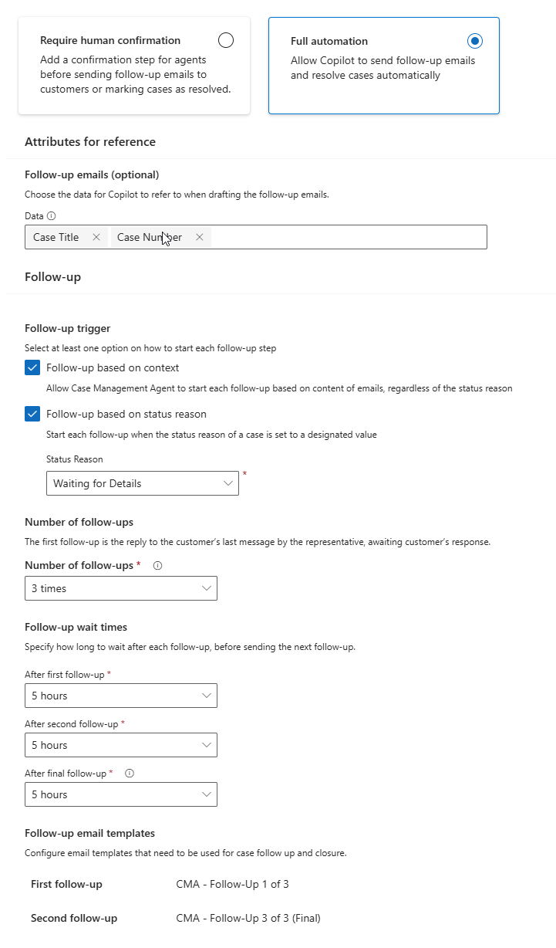
Figure 2 — Follow-up trigger, frequency (3×), wait times (5h each), and email template assignment

Step 3 — Case Created and CMA Begins Monitoring
With the rule saved, Henry's case is created and the agent sends the initial resolution email with the ERR-04 troubleshooting steps. The case status is set to Waiting for Details.
⚠️ Setting the status to Waiting for Details is the action that starts the CMA follow-up clock. Make sure every agent sets this status after sending an initial response.
Immediately after the status is set, CMA:
- Evaluates the case title → matches ERR- → Full Automation rule applies
- Detects status reason Waiting for Details → follow-up clock starts
- Drafts the first automated follow-up email using the configured template
- Schedules it to send automatically in 5 hours
In the Suggested actions panel, agents can see the upcoming follow-up and the exact time it will fire. A Preview button lets them review the draft — but no action is needed.
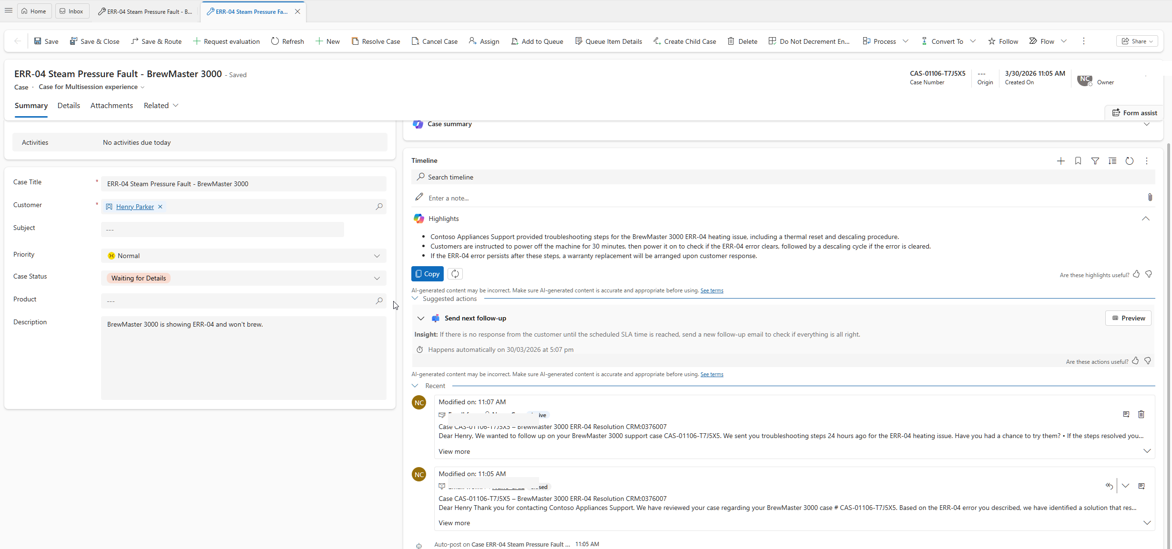
Figure 3 — Case created with Waiting for Details status — CMA schedules first follow-up automatically

Step 4 — Follow-Up 1 Sent, Next Draft Ready
Five hours after the case entered Waiting for Details, CMA sends the first automated follow-up email to Henry — no agent involvement required.
In the timeline:
- The follow-up email appears with status Inbox, confirming it was delivered to the customer
- CMA has already drafted the second follow-up and scheduled it for 5 hours later
- The Suggested actions panel updates to show the next scheduled send time
ℹ️ The case status remains Waiting for Details throughout the entire follow-up cycle. CMA continues monitoring as long as this status is set and the customer has not responded.
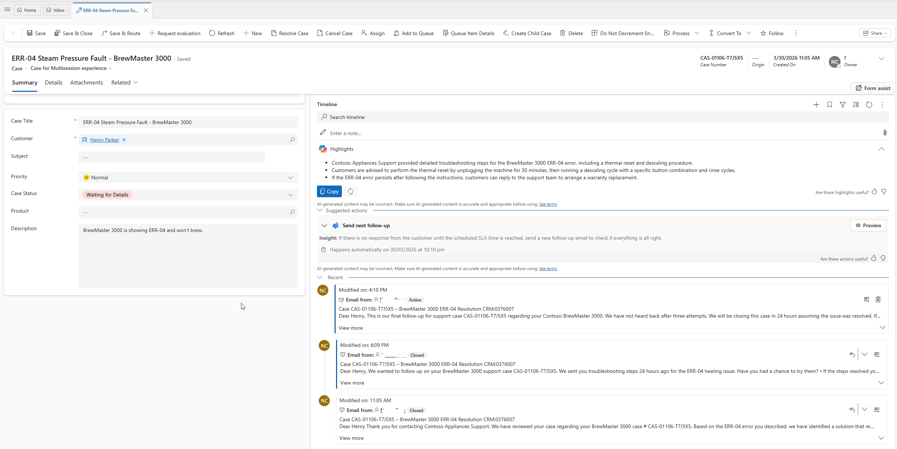
Figure 4 — Follow-up 1 sent autonomously — new draft prepared, next follow-up time visible in Suggested actions

Step 5 — Final Follow-Up Sent, Silent Closure Countdown Begins
At T+10h, CMA sends the second and final automated email to Henry. This email explicitly warns that no further communications will be sent and the case will close if there is no response. Key changes visible at this stage:
- Suggested actions changes from 'Send next follow up' to Resolve copy — follow-up cycle complete, next action is silent case closure
- The scheduled event shows a date/time for case auto-resolution — this is NOT another email, the case closes silently with no customer communication
- Case Summary highlights confirm: 'Multiple follow-up emails were sent to prompt customer response'
- All 3 emails in the timeline show status Closed
- The final email reads: 'This is our final follow-up... We have not heard back after three attempts...'
⚠️ No agent action is required. CMA closes the case at T+15h — no further email is sent to the customer after the final follow-up.
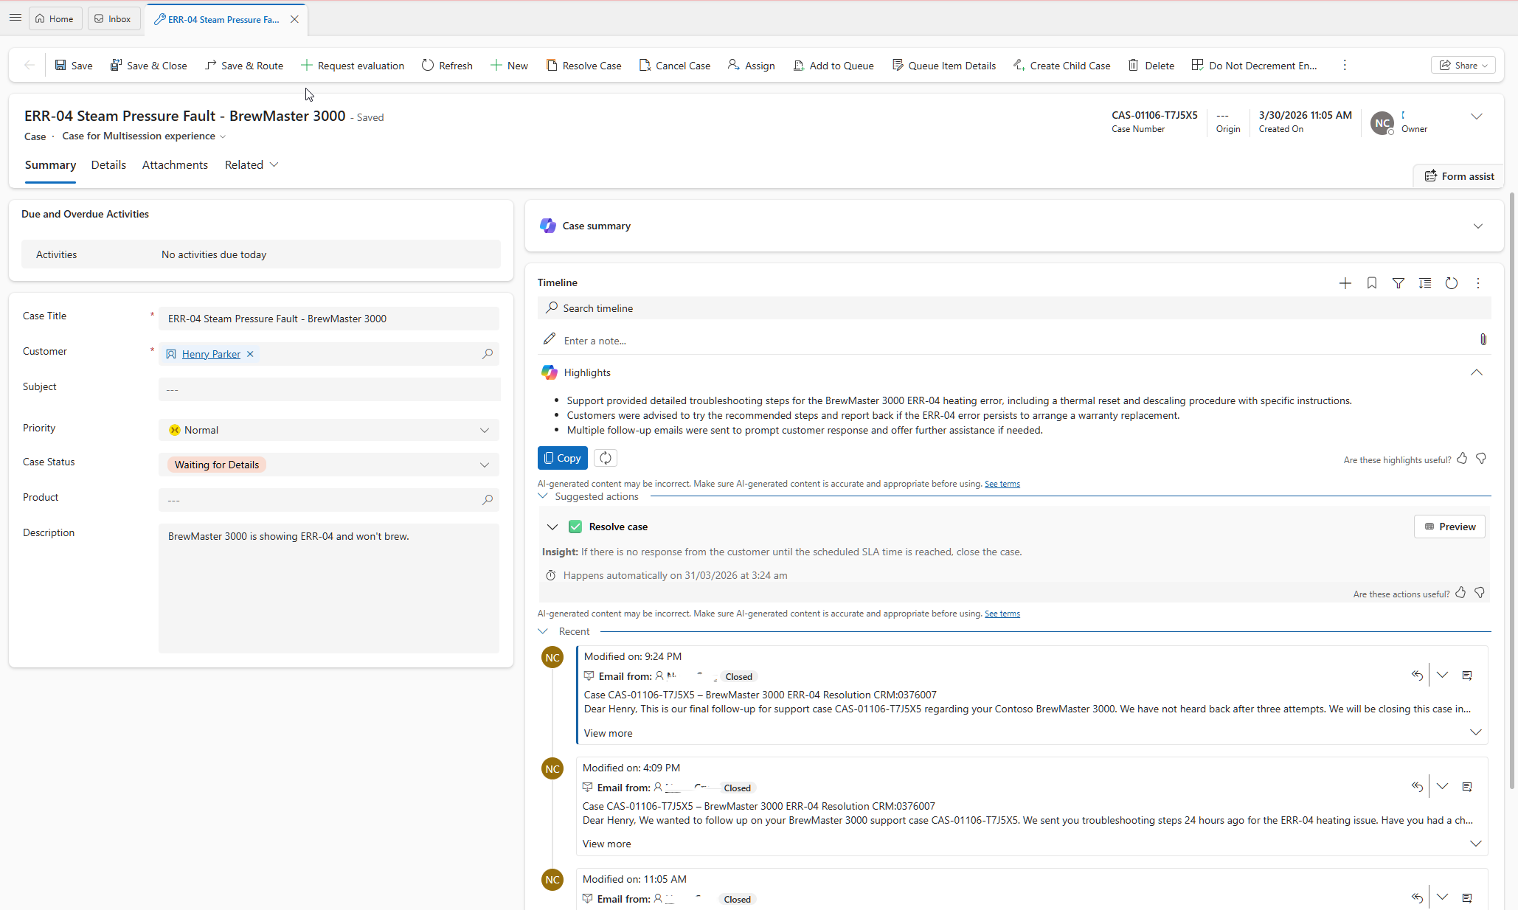
Figure 5 — All 3 follow-ups sent — Suggested actions shows Resolve copy with auto-closure countdown

Step 6 — Case Auto-Resolved by CMA
Henry never responded. CMA closes the case automatically. The case now shows:
- Case Status: Problem Solved — the case is resolved
- Read-only banner: 'Read only: This record's status: Resolved'
- No Suggested actions panel — CMA has nothing left to do
- Timeline shows all emails Closed and an auto-post confirming case resolution
- No new draft — the cycle is fully complete
The entire cycle — 3 emails over 10 hours followed by silent auto-resolution at T+15h — happened without a single agent touching the case after the initial email.
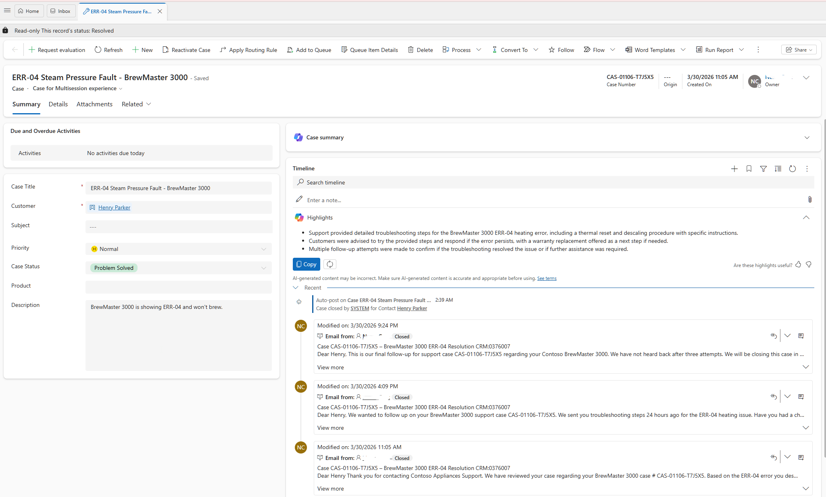
Figure 6 — Case automatically resolved by CMA after no customer response

Summary
Time | Event | Actor | Customer Comms
T+0 | Case created — agent sends resolution email — status: Waiting for Details | Agent | Email 1
T+5h | 1st automated follow-up sent | CMA | Email 2
T+10h | 2nd automated follow-up sent — warns case will close | CMA | Email 3 (Final)
T+15h | No response — case auto-resolved silently | CMA | No email

Key Takeaways
- Use Case Title Contains with OR logic to broadly catch all machine error patterns — not just specific codes.
- Use Full automation for known repeatable scenarios; use Require human confirmation for sensitive or commercial cases.
- The '3 times' follow-up count includes the initial agent email — CMA sends 2 additional automated emails, totalling 3 customer communications.
- The final automated email warns the customer the case will close — no surprise silent closure from the customer's perspective.
- After the final email, CMA waits the configured interval then closes the case silently — no additional email is sent to the customer.
- Waiting for Details is the critical status that starts the CMA follow-up clock — agents must set it after every initial response.
- CMA transitions automatically from follow-up mode to closure mode — no manual intervention needed at any stage.

Official Documentation
The following Microsoft Learn articles were used as reference for the configuration demonstrated in this guide.

Case Management Agent — Overview
Introduction to the Case Management Agent in Dynamics 365 Customer Service, including prerequisites, capabilities, and how to enable it in your environment.
https://learn.microsoft.com/en-us/dynamics365/customer-service/administer/set-up-autonomous-case-agents
Configure Follow-Up and Closure Rules
Step-by-step guidance for configuring follow-up and closure rules in the Case Management Agent, including automation levels, triggers, and wait times.
https://learn.microsoft.com/en-us/dynamics365/customer-service/administer/set-up-case-closure
Configure Email Templates for Case Management Agent
How to create and assign email templates used by the Case Management Agent for follow-up and closure communications.
https://learn.microsoft.com/en-us/dynamics365/customer-service/administer/configure-lob-email-templates
Use Case Follow-Up and Closure (Agent View)
Agent-facing documentation describing how the Case Management Agent handles autonomous follow-up and case closure from the agent's perspective.
https://learn.microsoft.com/en-us/dynamics365/customer-service/use/use-case-follow-up-closure

Dynamics 365 Customer Service | Case Management Agent | Microsoft Learn

